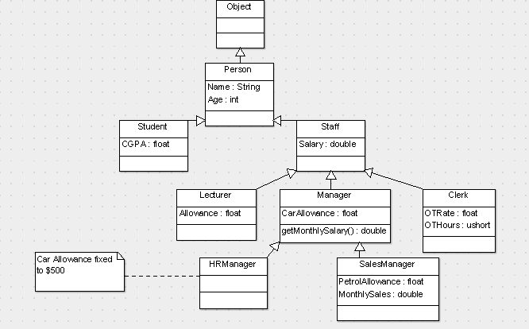

|  |  |
| --- | --- |
| Student.cs | |
| **Line** | **Code** |
| 1  2  3  4  5  6  7  8  9  10  11  12  13  14  15 | using System;  namespace University {  class Student:Person {  public float CGPA;  public Student(string name, float cgpa):base(name) {  CGPA = cgpa;  /*  * Another 100+ lines of common initialization logic  */  }  public Student():this("",0.0F) {  }  }  } |
| Person.cs | |
| **Line** | **Code** |
| 1  2  3  4  5  6  7  8 | namespace University {  class Person {  public string Name;  public Person(string name):base() {  Name = name;  }  }  } |

|  |  |
| --- | --- |
| Staff.cs | |
| **Line** | **Code** |
| 1  2  3  4  5  6  7  8  9  10  11  12 | using System;  namespace University {  abstract class Staff:Person {  public double Salary;  protected double EPF_CONTRIBUTON = 0.11;  public Staff(string name, double salary) : base(name) {  Salary = salary;  }  abstract public double getMonthlySalary();  }  } |

|  |  |
| --- | --- |
| Lecturer.cs | |
| **Line** | **Code** |
| 1  2  3  4  5  6  7  8  9  10  11  12  13  14 | using System;  namespace University {  class Lecturer:Staff {  public float Allowance;  public Lecturer(string name, double salary,  float allowance):base(name,salary) {  Allowance = allowance;  }  public override double getMonthlySalary() {  return (1.0 - EPF_CONTRIBUTON) * Salary + Allowance;  }  }  } |

|  |  |
| --- | --- |
| Clerk.cs | |
| **Line** | **Code** |
| 1  2  3  4  5  6  7  8  9  10  11  12  13  14  15  16 | using System;  namespace University {  class Clerk:Staff {  public float OTRate;  public ushort OTHours;  public Clerk(string name, double salary, float otRate)  :base(name,salary) {  OTRate = otRate;  OTHours = 0;  }  public override double getMonthlySalary() {  return (1.0-EPF_CONTRIBUTON) * Salary + (OTHours*OTRate);  }  }  } |

|  |  |
| --- | --- |
| Manager.cs | |
| **Line** | **Code** |
| 1  2  3  4  5  6  7  8  9  10  11  12  13  14  15 | using System;  namespace University {  class Manager:Staff {  public float CarAllowance;  public Manager(string name, double salary,  float carAllowance):base(name, salary) {  CarAllowance = carAllowance;  }  public override double getMonthlySalary(){//Operation (WHAT)  //Method (HOW)  return (1.0-EPF_CONTRIBUTON)*Salary + CarAllowance;  }  }  } |

|  |  |
| --- | --- |
| HRManager.cs | |
| **Line** | **Code** |
| 1  2  3  4  5  6  7  8  9 | using System;  namespace University {  class HRManager:Manager {  public HRManager(string name, double salary) :  base(name, salary, 500.0F) {  }  }  } |

|  |  |
| --- | --- |
| SalesManager.cs | |
| **Line** | **Code** |
| 1  2  3  4  5  6  7  8  9  10  11  12  13  14  15  16  17  18  19 | using System;  namespace University {  class SalesManager:Manager {  public float PetrolAllowance;  public double MonthlySales;  public SalesManager(string name, double salary,  float carAllowance, float petrolAllowance)  :base(name,salary,carAllowance) {  PetrolAllowance = petrolAllowance;  MonthlySales = 0.0;  }  override public double getMonthlySalary(){//Operation (WHAT)  //Method (HOW)  return (1.0 - EPF_CONTRIBUTON) * (0.6*Salary) +  (0.1*MonthlySales) + CarAllowance + PetrolAllowance;  }  }  } |