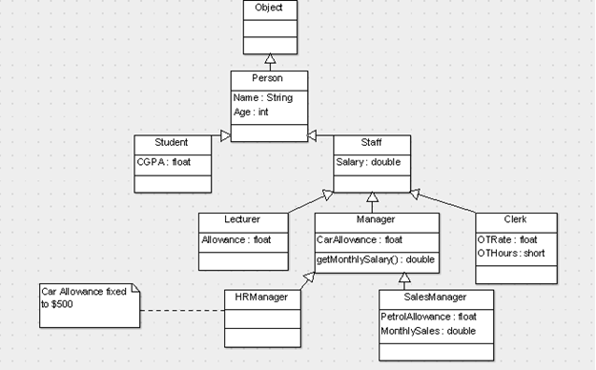

|  |  |
| --- | --- |
| Student.cs | |
| **Line** | **Code** |
| 1  2  3  4  5  6  7  8  9  10  11  12  13  14  15 | using System;  namespace University {  class Student extends Person {  public float CGPA;  public Student(string name, float cgpa):base(name) {  CGPA = cgpa;  /*  * Another 100+ lines of common initialization logic  */  }  public Student(){  super("",0.0F);  }  }  } |
| Person.java | |
| **Line** | **Code** |
| 1  2  3  4  5  6  7  8  9 | package University;  class Person {  public String Name;  public Person(String name){  super();  Name = name;  }  } |

|  |  |
| --- | --- |
| Staff.java | |
| **Line** | **Code** |
| 1  2  3  4  5  6  7  8  9  10  11 | package University;  abstract class Staff extends Person {  public double Salary;  protected final double EPF_CONTRIBUTON = 0.11;  public Staff(String name, double salary){  super(name);  Salary = salary;  }  abstract public double getMonthlySalary();  } |

|  |  |
| --- | --- |
| Lecturer.java | |
| **Line** | **Code** |
| 1  2  3  4  5  6  7  8  9  10  11  12  13  14  15 | package University;  class Lecturer extends Staff {  public float Allowance;  public Lecturer(String name, double salary,  float allowance){  super(name,salary);  Allowance = allowance;  }    @Override  public double getMonthlySalary() {  return (1.0 - EPF_CONTRIBUTON) * Salary + Allowance;  }  } |

|  |  |
| --- | --- |
| Clerk.java | |
| **Line** | **Code** |
| 1  2  3  4  5  6  7  8  9  10  11  12  13  14  15  16 | pacakge University;  class Clerk extends Staff {  public float OTRate;  public short OTHours;  public Clerk(String name, double salary, float otRate){  super(name,salary);  OTRate = otRate;  OTHours = 0;  }    @Override  public double getMonthlySalary() {  return (1.0-EPF_CONTRIBUTON) * Salary + (OTHours*OTRate);  }  } |

|  |  |
| --- | --- |
| Manager.java | |
| **Line** | **Code** |
| 1  2  3  4  5  6  7  8  9  10  11  12  13  14  15  16  17 | using University;  class Manager extends Staff {  public float CarAllowance;  public Manager(String name, double salary,  float carAllowance){  super(name, salary);  CarAllowance = carAllowance;  }    @Override  public override double getMonthlySalary(){//Operation (WHAT)  //Method (HOW)  return (1.0-EPF_CONTRIBUTON)*Salary + CarAllowance;  }  }  } |

|  |  |
| --- | --- |
| HRManager.java | |
| **Line** | **Code** |
| 1  2  3  4  5  6  7 | package University;  class HRManager extends Manager {  public HRManager(String name, double salary){  super(name, salary, 500.0F) {  }  } |

|  |  |
| --- | --- |
| SalesManager.java | |
| **Line** | **Code** |
| 1  2  3  4  5  6  7  8  9  10  11  12  13  14  15  16  17  18  19 | package University {    class SalesManager extends Manager {  public float PetrolAllowance;  public double MonthlySales;  public SalesManager(String name, double salary,  float carAllowance, float petrolAllowance){  super(name,salary,carAllowance);  PetrolAllowance = petrolAllowance;  MonthlySales = 0.0;  }    @Override  public double getMonthlySalary(){//Operation (WHAT)  //Method (HOW)  return (1.0 - EPF_CONTRIBUTON) * (0.6*Salary) +  (0.1*MonthlySales) + CarAllowance + PetrolAllowance;  }  } |